WashFold Orlando
Wash Operator Procedures Manual
Facility Wash & Fold Role — Step-by-Step Guide

1. Before You Start — Clock In
- Open the Operator app on your station device.
- Tap 🕐 Clock In.
- If you're outside your scheduled shift window, confirm the warning only if this is intentional.
Clock Out the same way at the end of your shift — always close out your time before leaving your station.

2. Logging In (PIN Gate)
After clocking in, enter your 4-digit PIN to unlock your queue.
- If you see "PIN not recognised," you mistyped it or your PIN isn't set up as an active Operator — check with your manager rather than guessing.
- You will only ever see orders assigned to you. If you open an order that isn't yours, the app will block it and show "Not assigned to you" — this is intentional, not an error to work around.

3. Printing the Bag Receipt — Now Done First
⚠ PROCESS UPDATE
Printing has moved to the start of the process. Print the bag receipt for a new order as soon as it lands in your queue — before weigh-in, washing, or folding.
At the Print Station, you'll see two tabs: To Print and Already Printed.
- Receipts print via the thermal (ESC/POS) printer and never show the customer's price — only bag count and identifying info.
- Print the receipt right away for each new order — don't wait until later in the process.
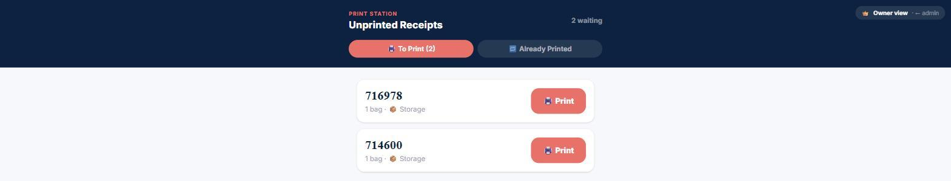
Print Station showing real unprinted receipts waiting to be printed, with bag count and floor/storage destination.

4. Your Queue — The Four Lanes
Your queue is organized into four lanes representing where each order is in the wash process:
Lane | What it means
🧺 Needs Loading | Order has arrived at the facility and is waiting to go into a washer.
🌀 In Washer | Order is currently washing.
💨 In Dryer | Order has moved from washer to dryer.
👕 Ready to Fold | Order is dry and waiting to be folded (or bagged, for Wash Only).

Move an order forward using these buttons as it progresses:
- Load into Washer — moves an order from Needs Loading into In Washer.
- Move to Dryer — moves an order from In Washer into In Dryer.
- Done Drying — Fold — moves a Wash & Fold or Comforter order into the folding step.
- Mark Ready (No Fold) — used instead, for Wash Only orders, which don't get folded.
- Mark Ready for Pickup — the final step once folding/bagging is done.
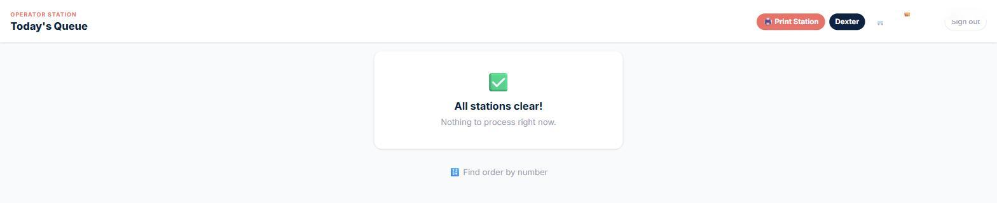
The station queue view — shown here with all stations clear. Your real queue lists orders in each lane during a shift.

4a. Selecting Which Machine You're Using
When you tap Load into Washer or Move to Dryer, you'll see a checklist of the washers or dryers currently set up for your facility.
- Check the box next to every machine you actually load this order into — you can select more than one if an order is split across machines.
- This is how the order's machine gets tracked, so always select the real machine(s) you use rather than skipping this step.
- If the list says "⚠️ No machines configured for this facility," don't guess — flag it to your manager so machines get added in Admin → Logistics.

5. Weigh-In
If a weight hasn't already been recorded for this order (e.g. by the driver at drop-off), you'll be prompted to enter it during processing.
- Weight must be greater than zero.
- Every order bills at a 20 lb minimum even if the actual weight is lower — this is expected, not an error.
- If a weight was already recorded earlier, the system automatically skips re-entering it — you won't accidentally double-charge a customer.

6. Detergent & Extras
Before washing, check the order screen for any detergent preference or extras (e.g. fabric softener, hypoallergenic detergent) the customer requested. These are shown directly on the order — always wash according to what's listed, not a default guess.

7. Folding Step
⚠ IMPORTANT
The folding-complete button will not activate until you've taken a folding photo. You'll see "📷 Take photo first" until this is done.
This photo is proof the order was actually completed and folded correctly — don't skip it or try to reuse an old photo.

8. Floor vs. Storage Decision
This decision still happens after folding, near the end of the process — it hasn't moved, only printing has.
- 📍 Keep at Facility — the order stays on-site, ready for pickup/delivery as normal.
- 📦 Send to Storage — the order is being held rather than immediately returned.
The same color-key sticker picker used by drivers is also available here if the color needs to be reassigned — yellow specifically means "sent to storage" and should only be used when you've selected Send to Storage.

9. Weight Discrepancy Warning
⚠ WEIGHT DISCREPANCY ≥ 4 LBS
If the intake weight and the folded weight differ by 4 lbs or more, you'll see a 🚨 Weight Discrepancy — Verify Items banner.
This is a soft warning, not a hard block — it's there so you double-check nothing was left in a washer/dryer or mixed into the wrong order before moving on.

10. End of Shift
- Confirm every order assigned to you today has reached Ready for Pickup (or been handed off appropriately).
- Double-check no new orders are sitting unprinted — receipts should already be printed from the start of each order's process.
- Tap Clock Out.

Questions about anything in this manual? Ask your manager before improvising — especially around weigh-ins, detergent instructions, and the floor/storage decision, since those steps directly affect what the customer is charged and receives.

